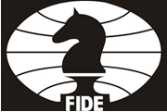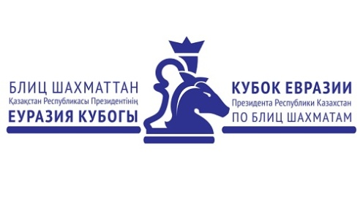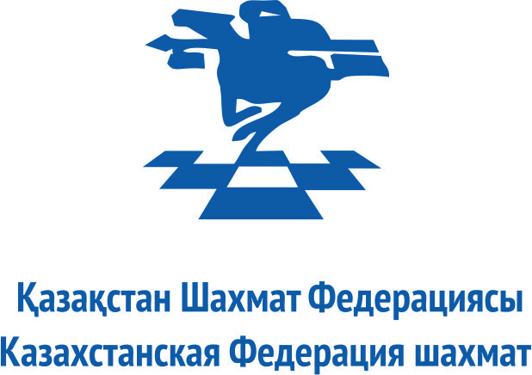

EURASIAN BLITZ CHESS CUP OF THE PRESIDENT OF KAZAKHSTAN
17-20 June 2016, Almaty, Kazakhstan
REGISTRATION FORM

Federation:
Address:
Mob:
E-mail:
Name of Player: |  |  |  | Male
 |  |  |  | Female
Title / ID Number | FIDE Rating | Passport No. | Date of Issue | Valid Until:
Country |  | Place of Birth | Date of Birth

Flight Details
Arrival Date: | Time:
Arriving From: | Flight No.:

Departure Date: | Time:
To: | Flight No.:

Name of Responding Official:

Please return this entry form by 17 May 2016 to the following email address:
office@kazchess.kz
Tel:+7(727)3494004, 3270204.

