
National Chess Federation of the Philippines
Rm 407 Bravo Bldg, Philsports Complex, Pasig City
Tel. +63 2 381-7224 Mobile:+63 929 239-0644, +63 928 551-3089
E-mail: NCFPsecretariat@yahoo.com

Manila, 15 March 2010

The President/Secretary
All ASEAN National Chess Federations

Dear Colleagues

11th ASEAN+ Age Group Chess Championships
Subic, Philippines – 4th to 13th June 2010

Following the string of successful Asian chess championships in Subic, the ASEAN Championships will be held in Subic Freeport, Olongapo City, Philippines from 4th to 13th June 2010. Participants may compete in the U-8, 10, 12, 14, 16 and 20 Age-Groups for Girls and Open. In addition, Seniors (aged 50 and above) will be held.

Subic is a well known resort which has played host to many World and Asian sports festivals. It is an ideal venue for youth events enclosed in a well guarded enclave with a number of recreational attractions for children. Many Asian chess championships have been successfully held in Subic which is about 2-1/2 hours from Manila or one hour from Clark air base.

The ASEAN+ Age Group Championships have grown in popularity and shall accept direct individual registrations as well as those from countries and territories around Asia.

Please kindly email your registration to us as soon as possible in order to ascertain the number of rooms required in the official hotel.

We look forward to welcoming you to Subic Freeport, Philippines!

Thank you so much.

Truly yours,

PROSPERO A. PICHAY, JR.
Chairman/President

Florencio Campomanes

President Emeritus

Hon. Prospero A. Pichay, Jr.

Chairman / President

Hon. Abraham N. Tolentino

Secretary General

Atty. Romeo Seratubias
Vice President (Luzon)

Bro. Rolando Dizon
Vice President (Visayas)

Valentino Rosabal
Vice President (Mindanao)

Red Dumuk
Treasurer

Atty. Raul Molintas
Auditor

IA Wilfredo A. Abalos
Executive & Events Director

IO / IA Casto P. Abundo
abundo@fide.com
FIDE Delegate

Atty. Edmundo Legaspi
Chairman for Membership

Saturnino Belen
Chairman for Publication

Edward De Luna
Chairman for Finance

Engr. Jesusito Legaspi
Chairman for Promotions &
Programs
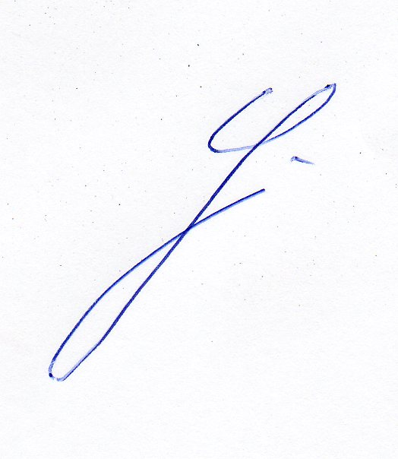
Hon. Matias Defensor
Judge Gonzalo Mapili
Hon. Thaddeus Santos
Atty. Manuel Relorcasa
Directors


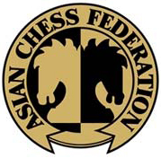
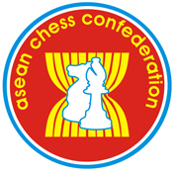

10th ASEAN+ AGE-GROUP CHESS CHAMPIONSHIPS
Subic, Philippines – 4th to 13th June 2010

Regulations

1. Eligibility & Participation:
1.1 Each country may register any number of players to participate. Individuals may also register directly. The players who are entitled to participate should not have reached their relevant age as on 1st January 2010.

2. Schedule
4th June after 1200 hours Arrival
2130 hours Technical Meeting
5th June 0900-1300 Standard Chess Round 1
1530-1930 Standard Chess Round 2
2000-2130 Opening Ceremony
6th June 0900-1300 Standard Chess Round 3
1530-1930 Standard Chess Round 4
7th June 0900-1300 Standard Chess Round 5
1900-2100 Social Nite
8th June Free Day - Several tours will be organised
9th June 0900-1300 Standard Chess Round 6
1530-1930 Standard Chess Round 7
10th June 0900-1300 Standard Chess Round 8
1530-1930 Standard Chess Round 9
11th June 0900-1300 Rapid Chess Rounds 1 to 4
1600-1900 Rapid Chess Rounds 5 to 7
12th June 0900-1300 Blitz Chess – 9 Rd Swiss (Team Result)
1500-1630 Blitz Chess – 4-game Semi-Finals & Finals
1900 hours Closing Ceremony
13th June before 1200 hours Departure

3. Pairing
In the last 2 rounds, where possible, players from the same country and who have more than 50% shall not be paired together.

4. Time Control
4.1 Standard Chess – Each player shall have 120 minutes to complete the game.
4.2 Rapid Chess – Each player shall have 25 minutes to complete the game.
4.3 Blitz Chess – Each player shall have 5 minutes to complete the game.

5. Medals
5.1 Medals will be awarded to the top three positions in each event and category (see 5.3).
5.2 Team Medals - will be awarded based on the total score of the top three players of a country. Countries with less than 2 players will not be eligible for a team award. In case of any tie, the tie-break scores of each player shall be considered (see 6.1)
5.3 Individual Medals - Where there is a tie, not more than 3 players will receive the same colour medal. For each category, not more than 5 medals will be awarded.
Examples - if 2 players tie for first and 2 players tie for third, then 2 Gold medals will be awarded, no Silver, but 2 Bronze medals will be awarded. If 3 players tie for first, then no Silver and Bronze medals will be awarded. If more than 3 players tie for first, then the 3 highest based on tie-break will receive the Gold medals and the Silver and Bronze medals will not be awarded.
5.4a For the Standard Chess events, FM/WFM titles are awarded to the winners (regardless of ASEAN or non-ASEAN players) of the youth categories. In case of tie, after tie-break, only the top three will be awarded. CM/WCM titles are awarded, after tie-break, to silver and bronze medal winners – not more than one title will be awarded for each (2nd/3rd) position.
5.4b The IM/WIM titles are awarded for the ASEAN U20 category.
5.5 To retain the ASEAN spirit, in categories where there are less than 3 non-ASEAN medalists, additional medals will be awarded to the highest placed players from ASEAN.

6. Tie-Break
6.1 Swiss-System : Buchholz, followed by Sonneborn-Berger; Number of Wins with the Black pieces.
6.2 Round-Robin : Sonneborn-Berger; Direct Encounter; Number of Wins with the Black pieces.

7. Appeals Committee
The Appeals Committee will be decided during the technical meeting. An appeal, accompanied by a deposit of US$50, must be submitted within 15 minutes of the completion of the relevant playing session.

8. Registration Fee

Registration Date | Players Through Federation | Players with Direct Registration | All Accompanying Persons
Before and on 15th May 2010 | US$ 200 | US$ 250 | US$ 75
After 15th May 2010 | US$ 250 | US$ 300 | US$ 125

9. Official Hotel & Venue
9.1 The Official Hotel is the 3-star Subic International Hotel.
9.2 All players and accompanying persons shall have to be registered through the organisers at the designated official hotel.
9.3 The organisers shall provide free board and lodging to one official or coach per Federation on triple-sharing basis. The room rates (inclusive of 3 meals per day) shall apply to all players and accompanying persons:
Payment of Fees | Single | Twin/Double | Triple
Before and on 15th May 2009 | US$ 78 | US$ 63 per pax | US$ 55 per pax
9.4 For every 5 players registered through the Federation, board and lodging shall be waived for the 6th player. Rooms are assigned on triple-sharing basis.

10. Transportation
The registration fee includes airport transfers. Details of Flight Arrival must be provided before 1st June 2010 otherwise no transfers will be arranged. It takes some 2-1/2 hours each way from Manila, and around an hour from Clark.

11. Entry Visas
Participants may get their visas at the Philippine Embassy in their respective countries.

12. Social Nite
This event is an opportunity for the players to perform and show their talent other than Chess. Participation is limited to one presentation per country. Please bring your own musical instruments or accompanying CD/VCD. Prizes will be awarded.

13. Registration of Participants and Accompanying Persons

Please send your registration and provide the Name, Sex, Date of Birth, FIDE Rating/ID Number (if any), type of room and rooming list to:

Asean Chess Confederation: c/o Mr Ignatius Leong
Block 231 Bishan Street 23 #10-13, Singapore 570231
Fax : (65) 62551370 or (65) 63581483

Or email: NCFPsecretariat@yahoo.com and/or email: ignatiusleong@pacific.net.sg
Copy: abundo@fide.com

The deadline for registration is 15th May 2010.

Players who are absent at the Technical Meeting shall not be paired for Round 1.

For every player or accompanying person who registered but does not turn up, a penalty of US $25 shall be imposed on the federation.

14. Payments
All payments (net of all bank charges) shall be made payable to:

Intchess Asia Pte Ltd

DBS Bank, Singapore

Account Number: 0070 - 000512 – 01 - 0
Swift Code: DBSSSGSG

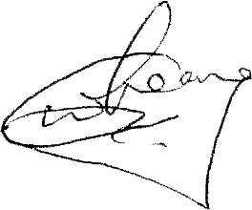

Ignatius Leong
President
ASEAN Chess Confederation

