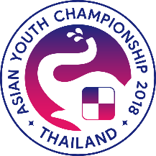
Asian Youth Chess Championships 2018
Under 8, 10, 12, 14, 16 and 18 (Standard, Rapid and Blitz)
Chiang Mai, Thailand, 31 March – 9 April 2018

Federation: ___________________
Registration form for all participants

 | Passport Information |  |  |  |  |  |  | Player Information
No | Surname | First Name | Passport No | Issue Date | Expiry Date | Birth Date | Birth Place | FIDE ID | Title | FIDE Rating | Status | Age Group
Trainer
1
2
3
4
5
6
7
8
9
10
11
12
13
14
15
16
17
18
19
20
Status are Official player ( I ), personal right (P), Accompanying Person (A), Extra player (E)
Arrival Details: Date: Time: Airline: Flight No.:
Departure: Date: Time: Airline: Flight No.:
Number of requested hotel rooms: Double _____ Single _____

Federation Official: Name Signature:

