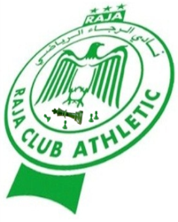
Registration form at
9th International Open
Trophy Mohammed Sekkat
From 25 Nov to 1st Dec 2016

I, Full name in Arabic and Latino characters: …………………………………………………
No license or ID FRME national identity card:………………………………….

Club Name: ........................... …………………………No. FIDE ID: ........................ ..

Port No. passes (for foreigners only):……………………………………

I participate in: 9th International Open trophy Sekkat:

Championship Morocco veterans (+50 years):

Tournament categories under 16 years:

I have the honor to request the President of the organizing committee to accept my request to participate in the 9th International Trophy the Mohammed Sekkat organized by FRME of 25 November to 1 December 2016 in Tangier.

• I confirm not to abandon me or absent during the tournament without notifying the front by the president of the organizing committee. I also agree to respect the statutes and internal regulations of the open.

• I also agree to:
- Adjust the participation fee before the start of the tournament
- Wear the badge during the tournament and for the accommodation and food.
- Respect the schedules of the game, catering and attend the opening and closing ceremony.

• In case of withdrawal without cause or without the agreement of the President of the organizing committee, I will refund the costs incurred by the FRME under accommodation and catering.
- Formal prohibition for national players to drink alcoholic beverages during the tournament.
- No smoking inside the hall of the game.
- Observing the full respect of internal rules and fair play.

• I chose (put a think about the appropriate box):
- Accommodation: - Food:

Travel Information (only for foreigners):
Arrival date :
Arriving time :
Date of departure :
Departure time :

NB: this form must be completed carefully and send it to the email FRME. frmechecs1963@gmail.com or amzal90@gmail.com

